### Standing a Slice form Egg on End for the Equinox

Spring is officially here and I made a slice form egg to celebrate its arrival.

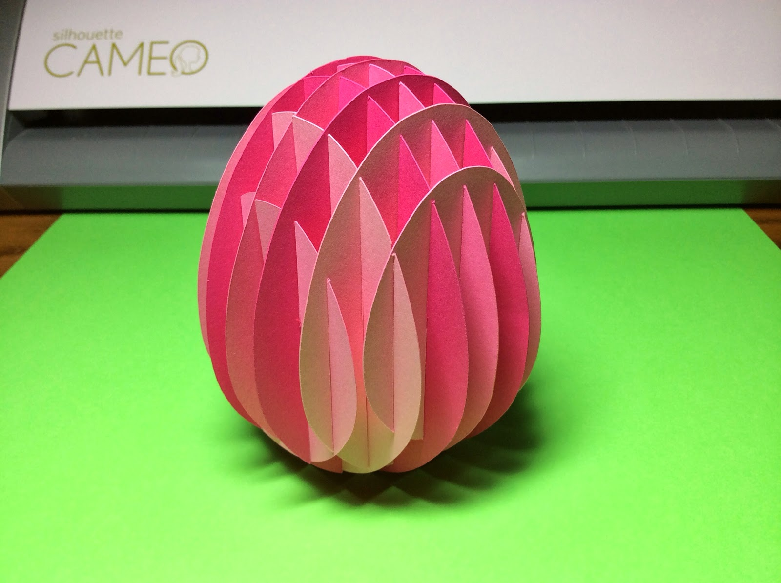

This slice form egg can stand on its end without any assistance.

The tilt of the earth's axis determines our seasons. When the sun is at its furthest angle away, we have winter with its shorter daylight hours. When the sun is at its closest angle, we have summer with its longer daylight hours. When the tilt is the same, the daylight and night hours are equal in length. It is called an equinox. This equinox occurs twice a year on March 20 and September 22. These dates signify the start of spring and fall. There is a belief that on these dates that you can stand an egg on end because of the alignment of the gravitational pull. This equality in gravitational pull is supposed to help balance any object. Sadly, this is a fallacy. You can stand an egg on end at any time of the year. Oh well, it's an interesting concept to ponder anyway.

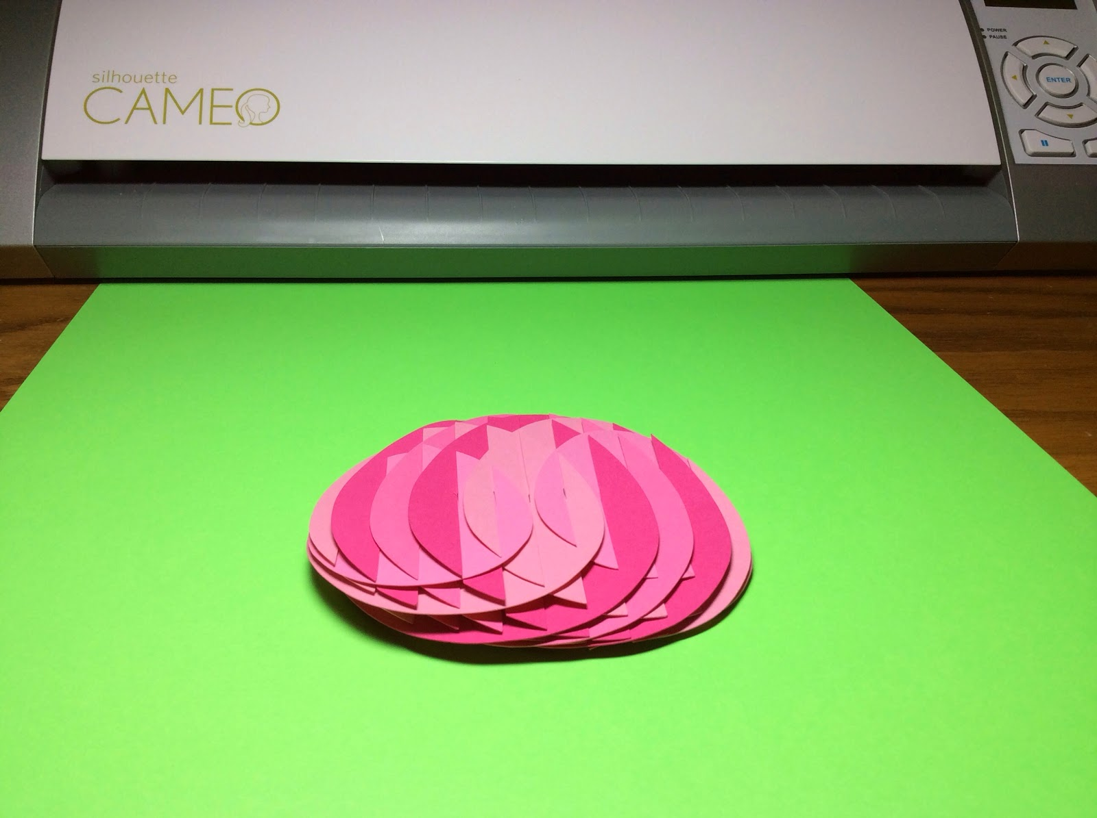

This slice form egg can also lie flat for mailing.  
  
Happy Spring!